
CONFIDENTIAL CS/NOV 2026/CSC429

UNIVERSITI TEKNOLOGI MARA FINAL EXAMINATION

COURSE
COURSE CODE
EXAMINATION TIME
COMPUTER ORGANIZATION AND ARCHITECTURE

CSC429
NOVEMBER 2026
3 HOURS

INSTRUCTIONS TO CANDIDATES

- This question paper consists of two (2) parts: PART A (10 Questions) PART B (1 Question)

- Answer ALL questions in the Answer Booklet. Start each answer on a new page.

- Do not bring any material into the examination room unless permission is given by the invigilator .
- Please check to make sure that this examination pack consists of: i) the Question Paper
  - an Answer Booklet - provided by the Faculty

- Answer ALL questions in English.

DO NOT TURN THIS PAGE UNTIL YOU ARE TOLD TO DO SO

This examination paper consists of 4 printed pages.

PART A (80 MARKS)
Answer ALL questions in this part.
QUESTION 1 (5 marks)
- The Von Neumann Architecture was first introduced inwhich computer generation?
- Draw the Von Neumann Architecture.
- Central Processing Unit (CPU) is one of the components of a Von Neumann Architecture
whereas Control Unit and Arithmetic Logic Unit are the main components of a CPU. What
is the main task of a CU?
QUESTION 2 (5 marks)
List the name of the inventor of the following devices:
- Mechanical Calculating Machine
- Difference Machine
- Analytical Machine
- IAS Machine
- Integrated circuit
QUESTION 3 (5 marks)
Differentiate between DRAM and SRAM in term of the following characteristics:
- Speed.
- Size per bit.
- Cost.
- Type of bits stored.
- Refreshing need when powered.
QUESTION 4 (5 marks)
- What is a cache?
- Describe TWO (2) ways to store data in cache.
QUESTION 5 (10 marks)
- Describe THREE (3) types of interfaces to external devices.
- Explain TWO (2) types of interrupt.
QUESTION 6 (10 marks)
Describe FOUR (4) classifications of multiple processor architecture with an example each.
QUESTION 7 (10 marks)
- Differentiate between organization and architecture.
- Explain the function of THREE (3) Central Processing Unit (CPU) components.
QUESTION 8 (10 marks)
- convert 46.0703'125n to a floating-point number in IEEE single precision format in
hexadecimar varue form. show your comprete workflow'
- Convert 8F080000rr in IEEE single precision floating point number to decimal value form.
Show your workflow.
QUESTION 9 (10 marks)
Question 9 is based on Figure 1. Figure 1 illustrates the multiple interrupts that occur in a
computer system.
- Define interrupt.
- Rank the interrupts based on their priority from the most important to the least important.
- Rank the interrupts from the most important to the least important if disable interrupt is
applied.
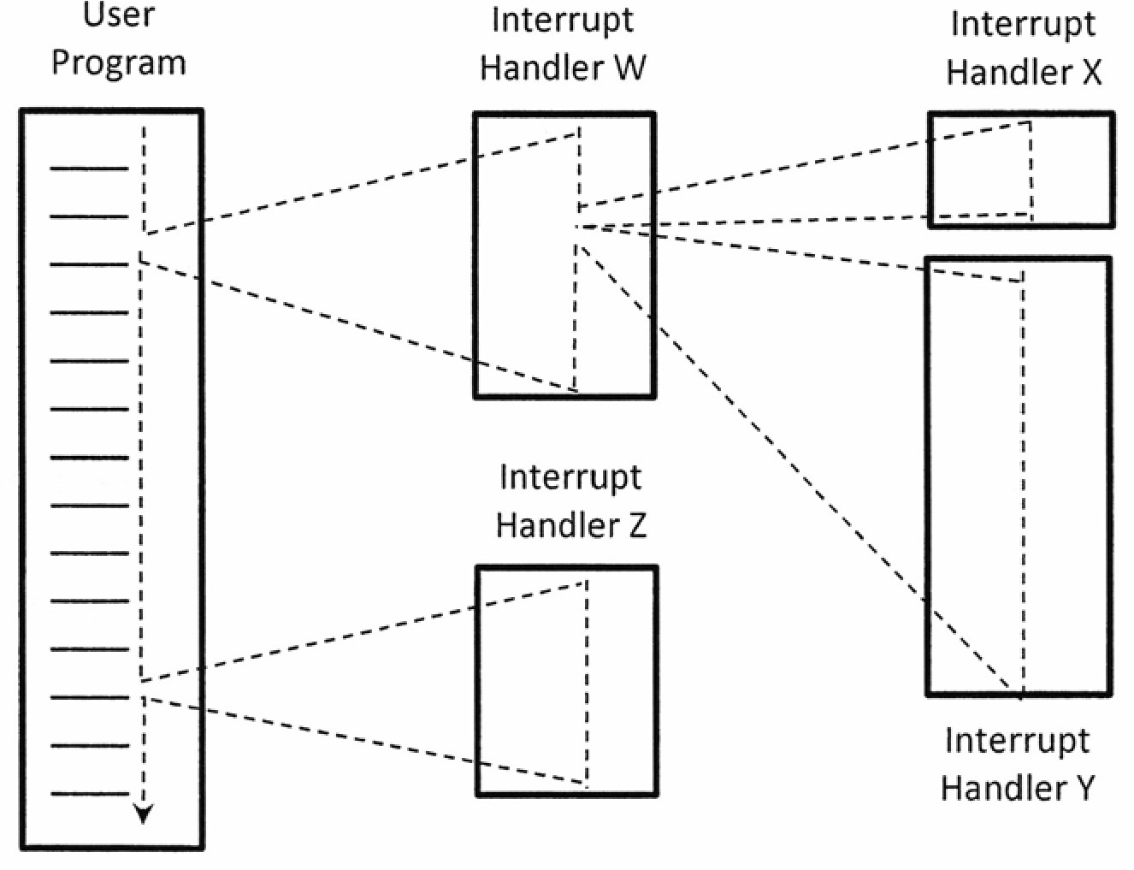
Figure 1: Multiple interrupts
QUESTION 10 (10 marks)
Describe the function of each register in the computer system.

PART B (20 MARKS)
Answer the question in this part.
QUESTION 11 (20 marks)
Question 1 is based on Figure 2 and Table 1.
Write the appropriate programs using correct assembly language notations and comments to
compute the equation represented in Figure 2 using one-, two- and three-address
instructions. The instructions available for use are provided in Table 1. Note that Register A,
B, C, D, E and F cannot be modified and Register X, Y and Z can be used as temporary
register. Final answer must be stored in Register X.
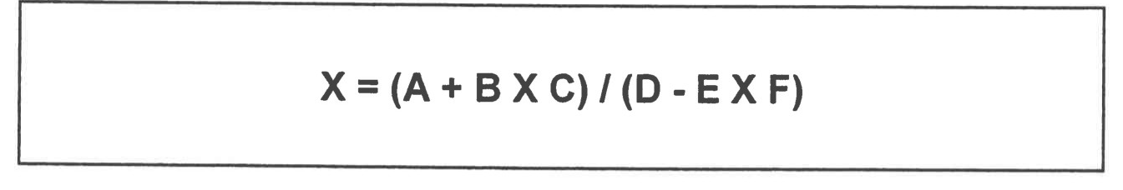
Figure 2
Table 1 : Machine Instruction
i Nia dress |  | address
LOAD M | MOVE (X e Y) | MOVE (X e Y)
STORE M | ADD (X k.. X + Y) | ADD (X e Y + Z)
ADD M | SUB (X e X - Y) | SUB (X e Y-Z)
SUB M | MUL (X e X x Y) | MUL (X e Y x Z)
MUL M | DIV (X e x / Y) | DIV (X e Y / Z)
DIV M

